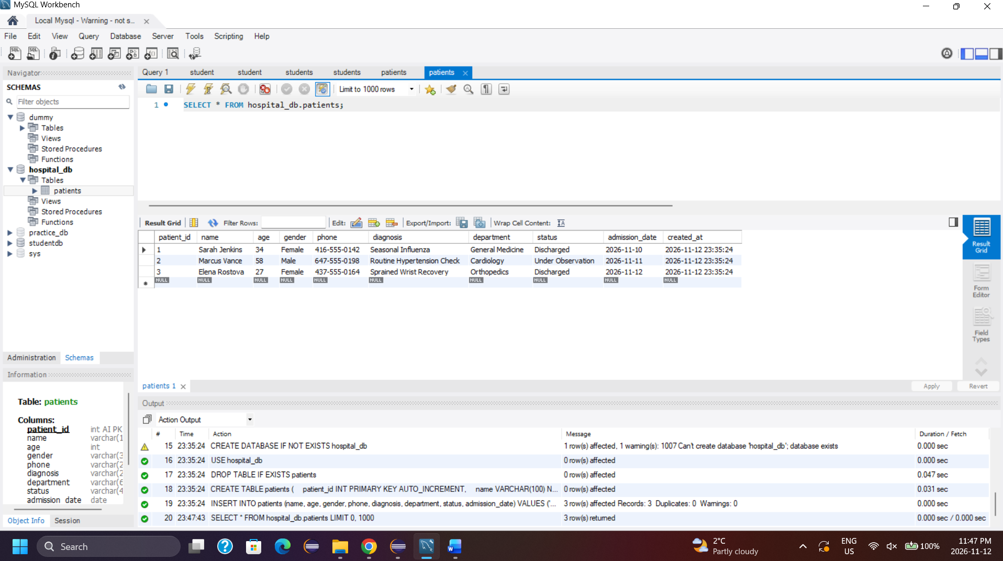
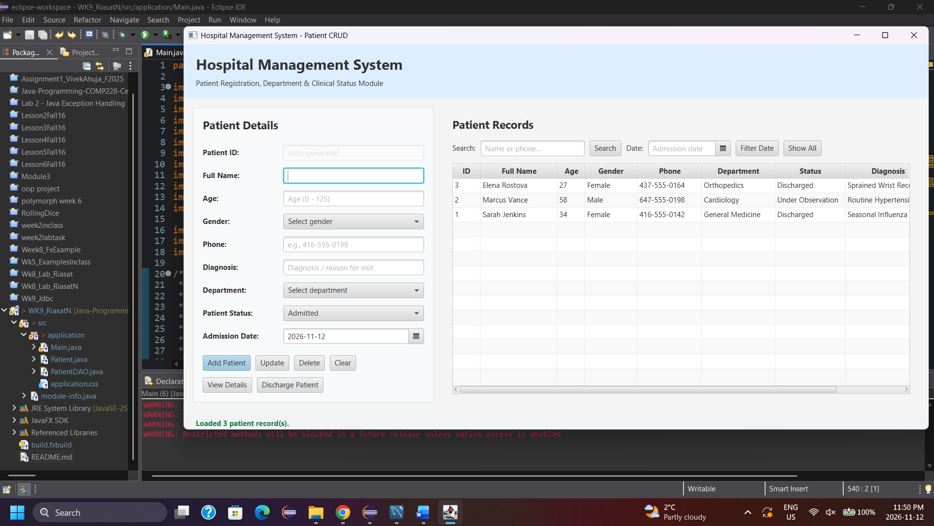
CREATE — Add Patient (handleAdd / PatientDAO.insertPatient):
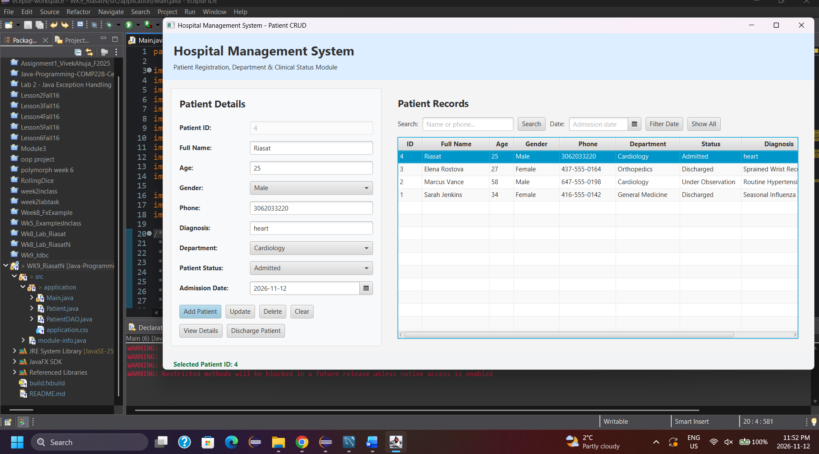
Validates that all required fields (name, age, gender, phone, diagnosis, department, status, and admission_date) are provided, confirms age is a whole number between 0 and 125, checks phone formatting via regex, and ensures admission_date is not in the future. Connects to jdbc:mysql://localhost:3306/hospital_db via DriverManager.getConnection() and executes a parameterized INSERT INTO patients ... VALUES (?, ?, ?, ?, ?, ?, ?, ?) using PreparedStatement.executeUpdate() inside a try-with-resources block, then refreshes the TableView and clears the form.
READ — Show Patients (loadPatients / PatientDAO.getAllPatients):
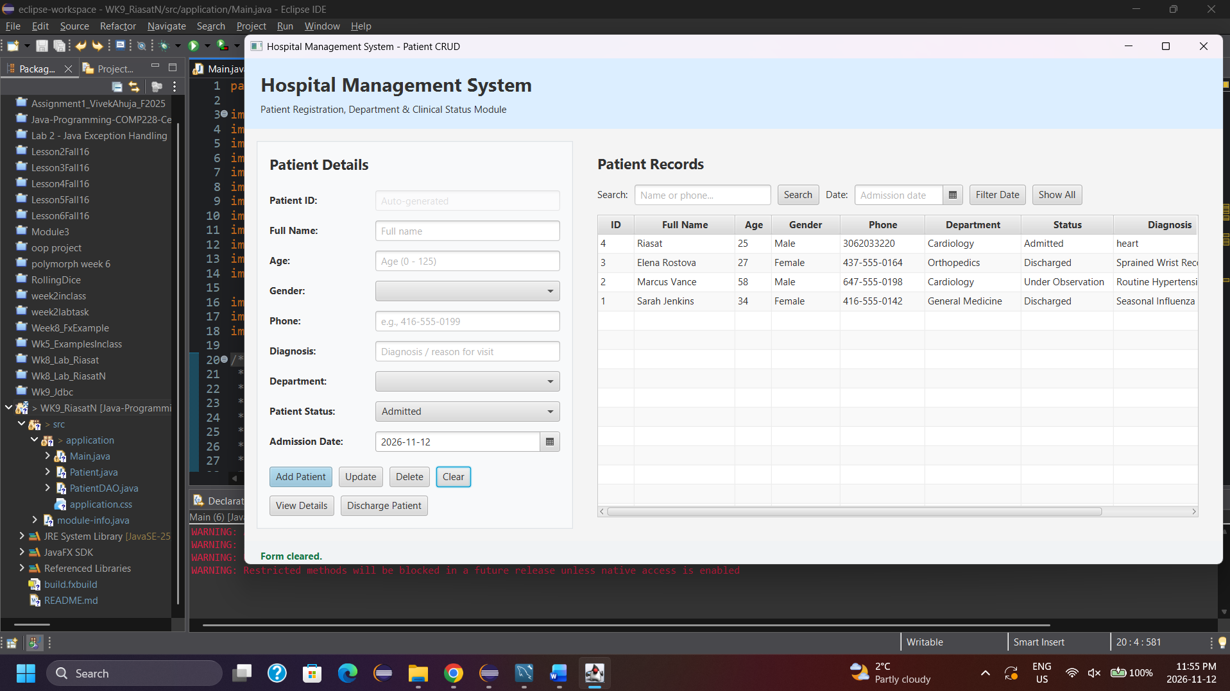
Executes a SELECT query ordered by patient_id DESC using PreparedStatement.executeQuery(). Iterates through the ResultSet to instantiate Patient objects and updates the ObservableList<Patient> bound to the TableView. Clicking any row in the TableView triggers a selection listener that populates the left-hand form with that patient's details.
UPDATE — Edit Patient (handleUpdate / PatientDAO.updatePatient):
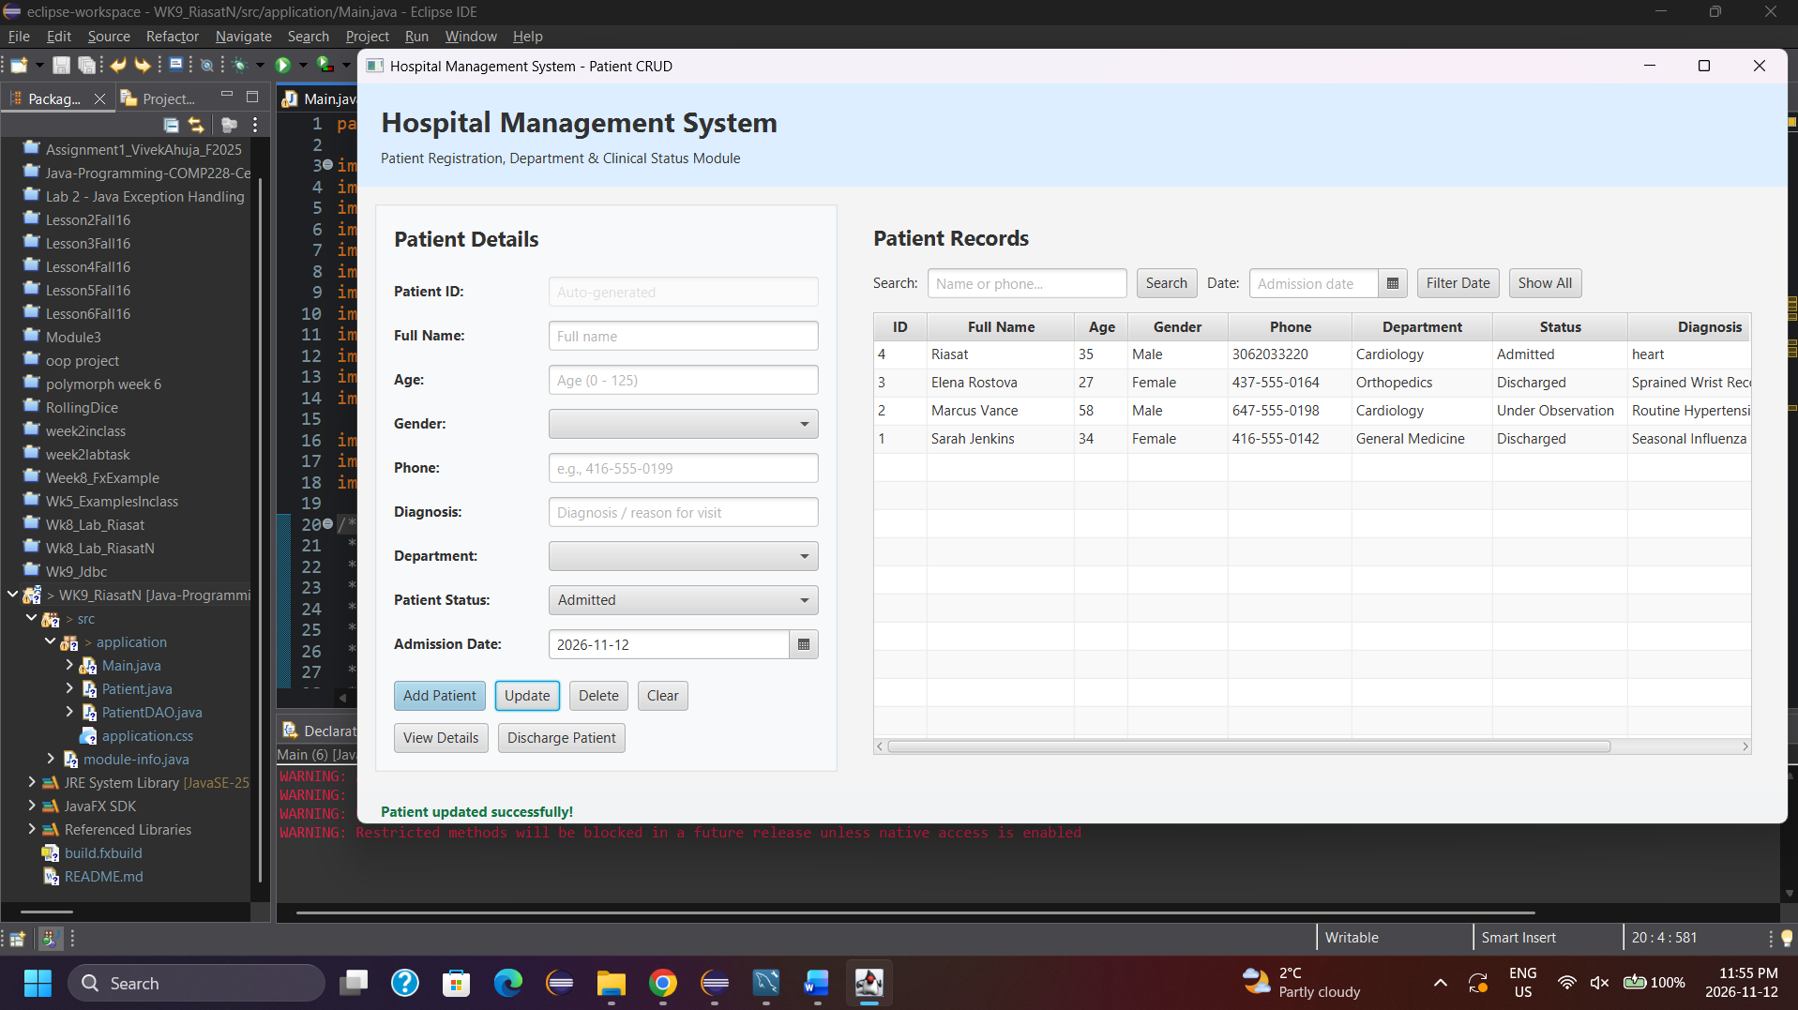
Requires a selected patient row (patient_id) and validates all modified fields. Executes a parameterized UPDATE patients SET ... WHERE patient_id = ? statement via executeUpdate(), reloads the TableView, and displays a green confirmation status message.
DELETE — Remove Patient (handleDelete / PatientDAO.deletePatient):
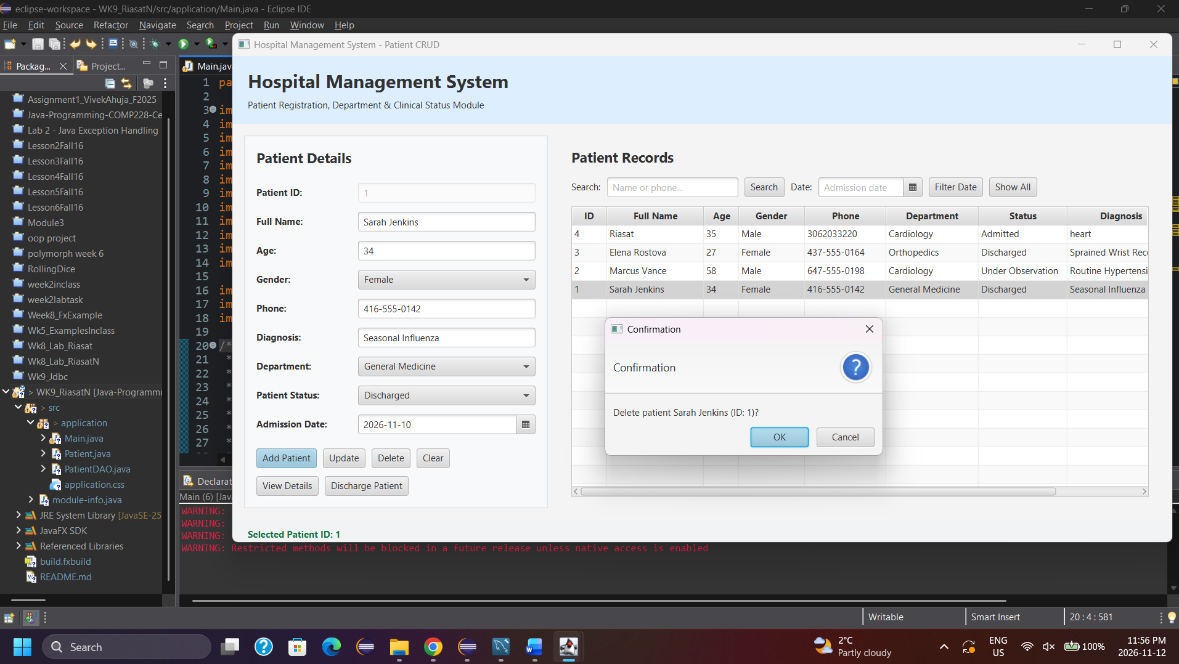
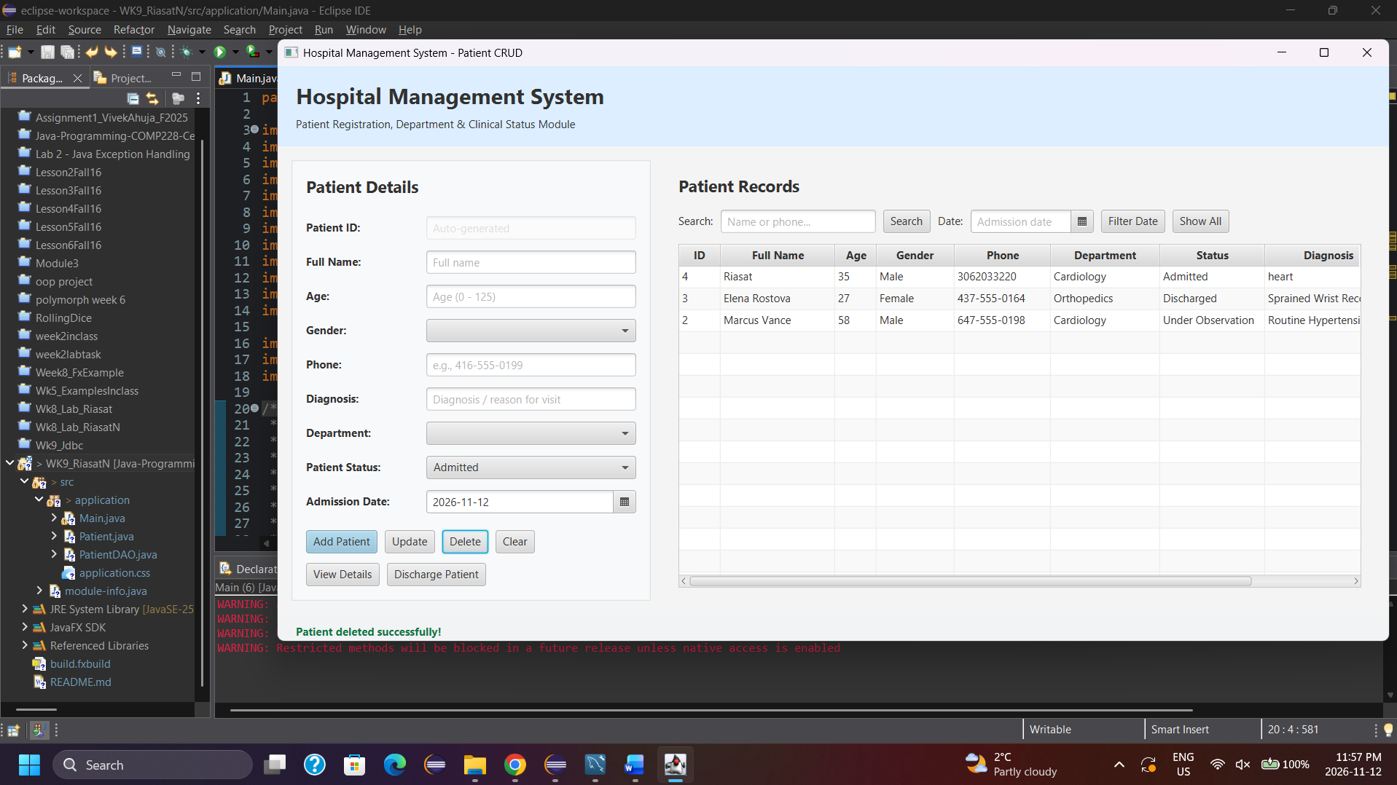
Prompts the user with a JavaFX Alert(AlertType.CONFIRMATION) dialog displaying the selected patient's name and ID. If confirmed (ButtonType.OK), executes DELETE FROM patients WHERE patient_id = ? via PreparedStatement.executeUpdate(), refreshes the TableView, and resets the form.
SEARCH & EXTENSIONS (searchPatients, filterByAdmissionDate, dischargePatient, handleViewDetails):
- Name/Phone Search:
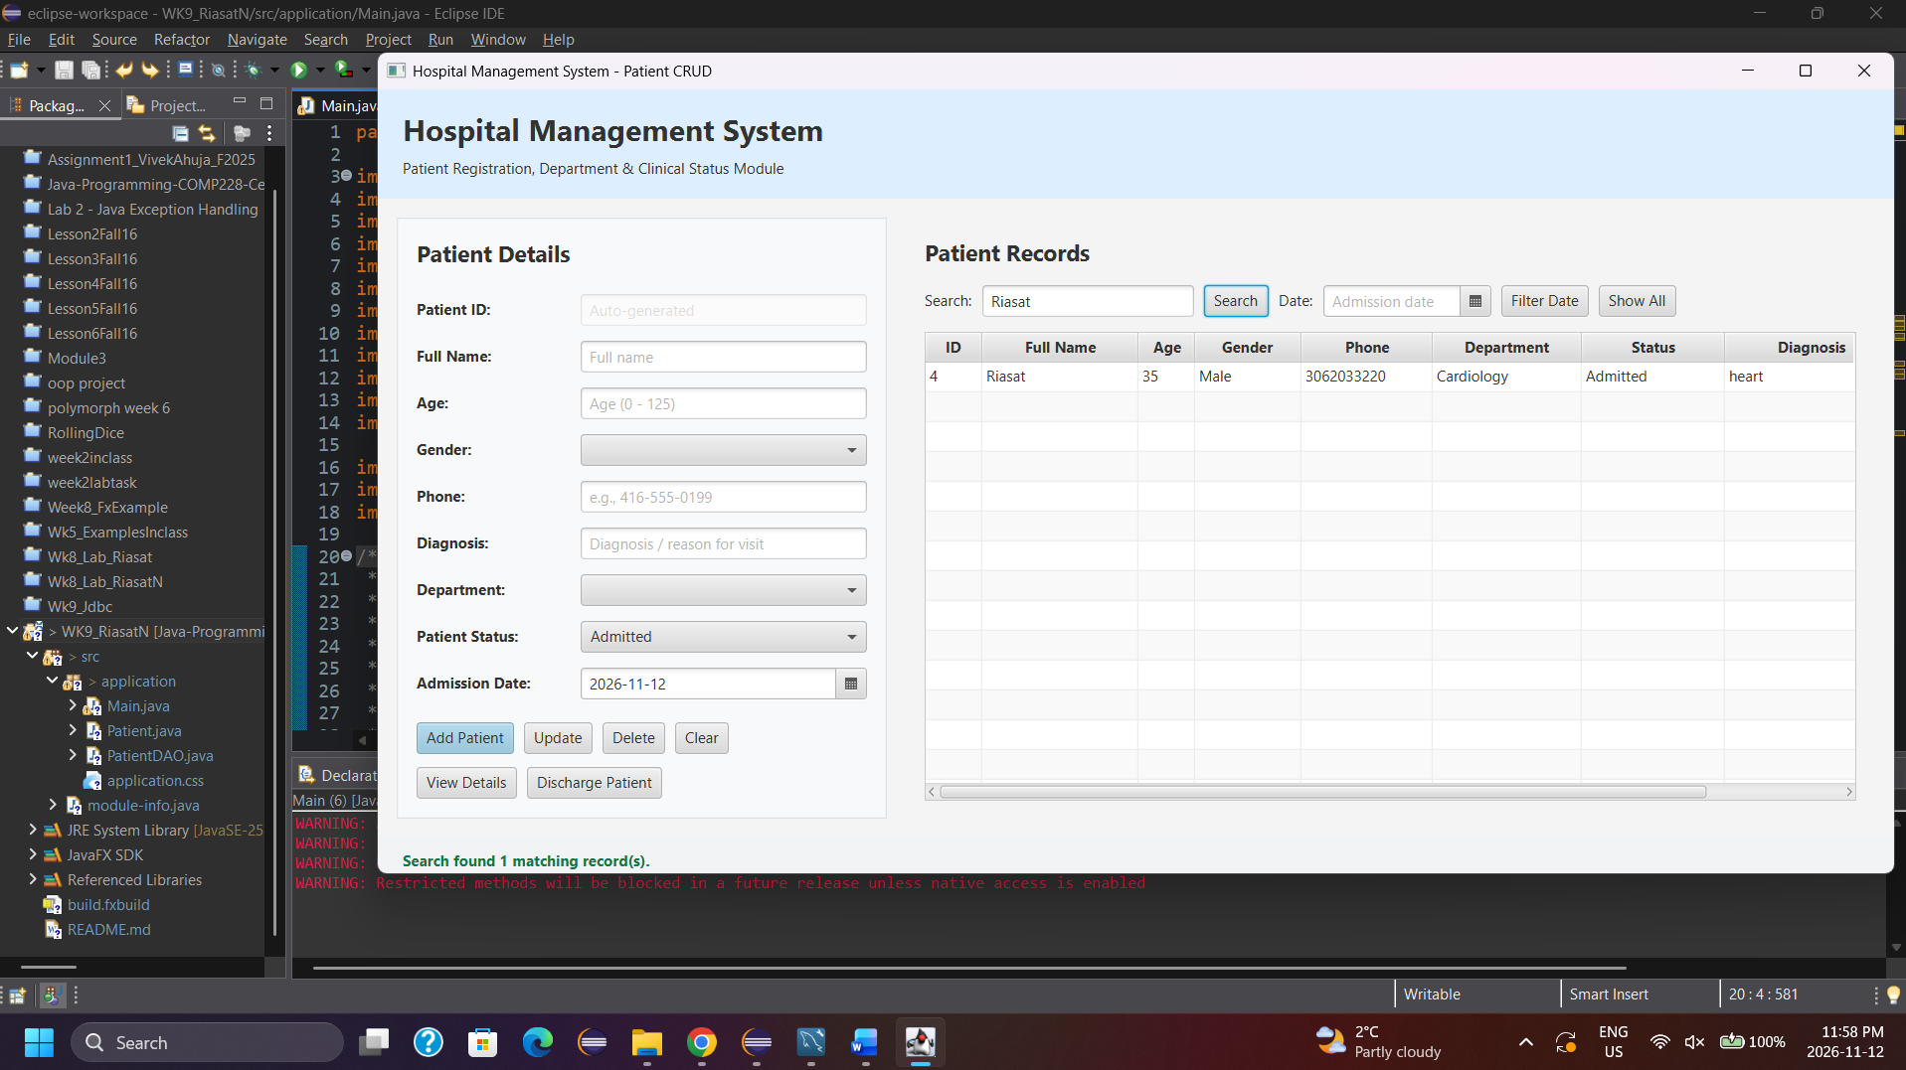
Uses a parameterized SELECT ... WHERE name LIKE ? OR phone LIKE ? query with "%" + keyword + "%" to filter records safely without SQL injection.
- Admission Date Filter:
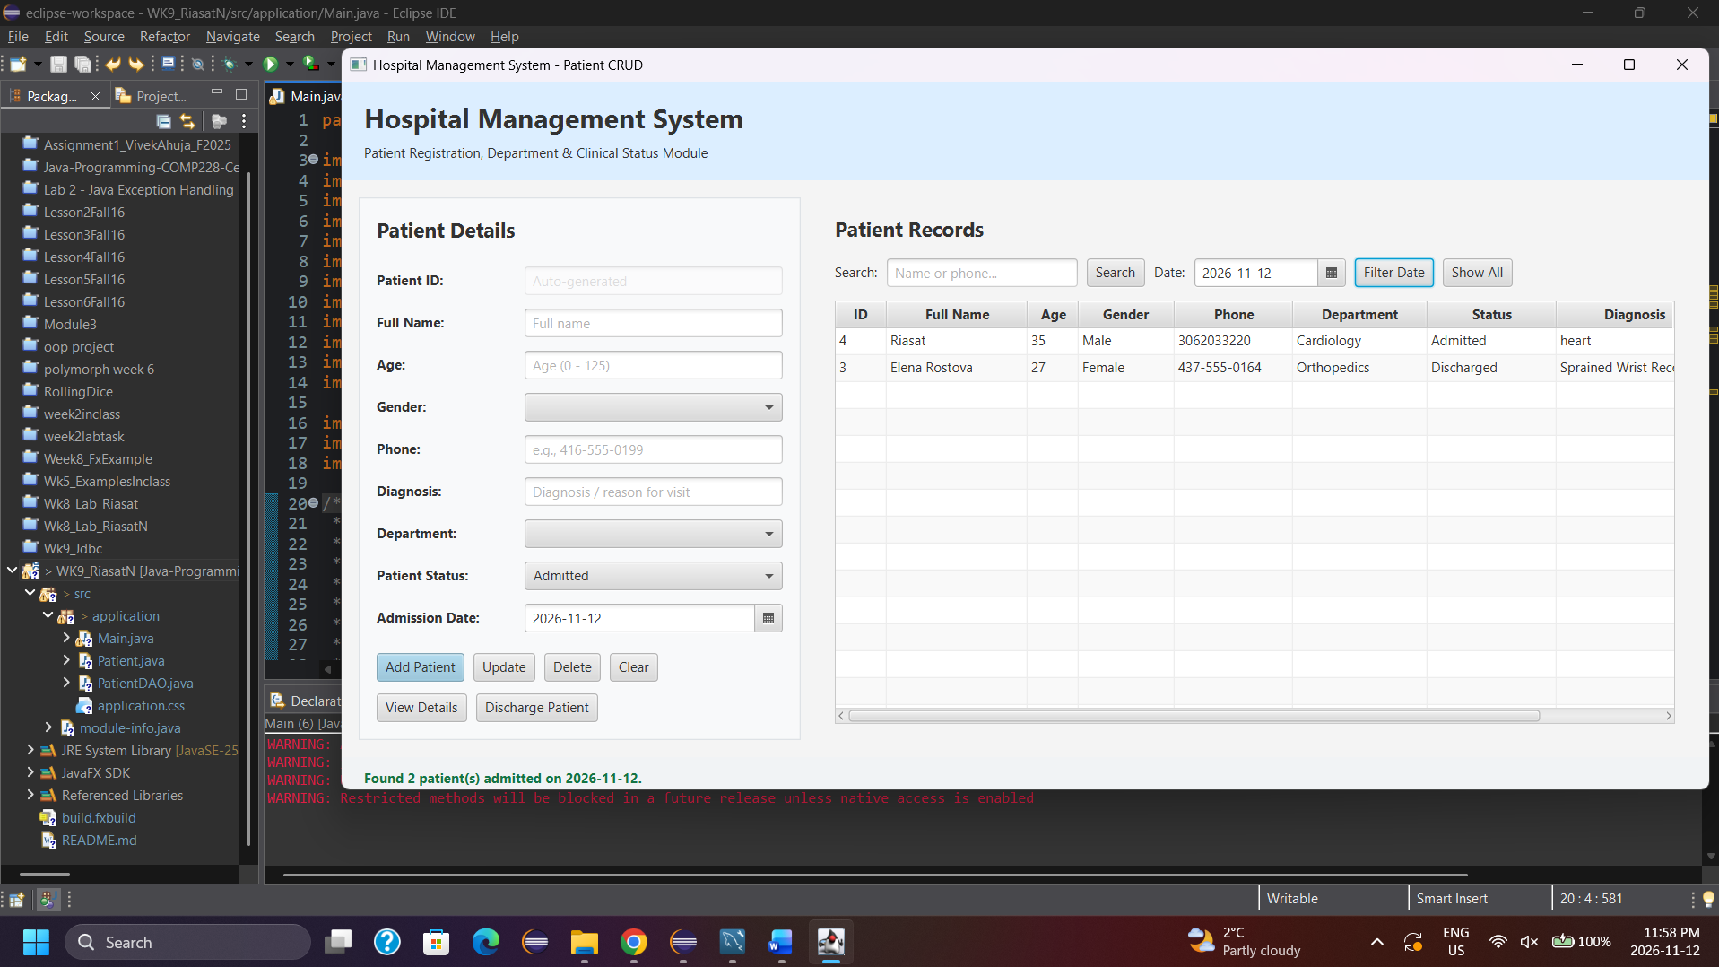
Filters the TableView for patients admitted on a specific date using WHERE admission_date = ?.
- Quick Discharge & Details View:
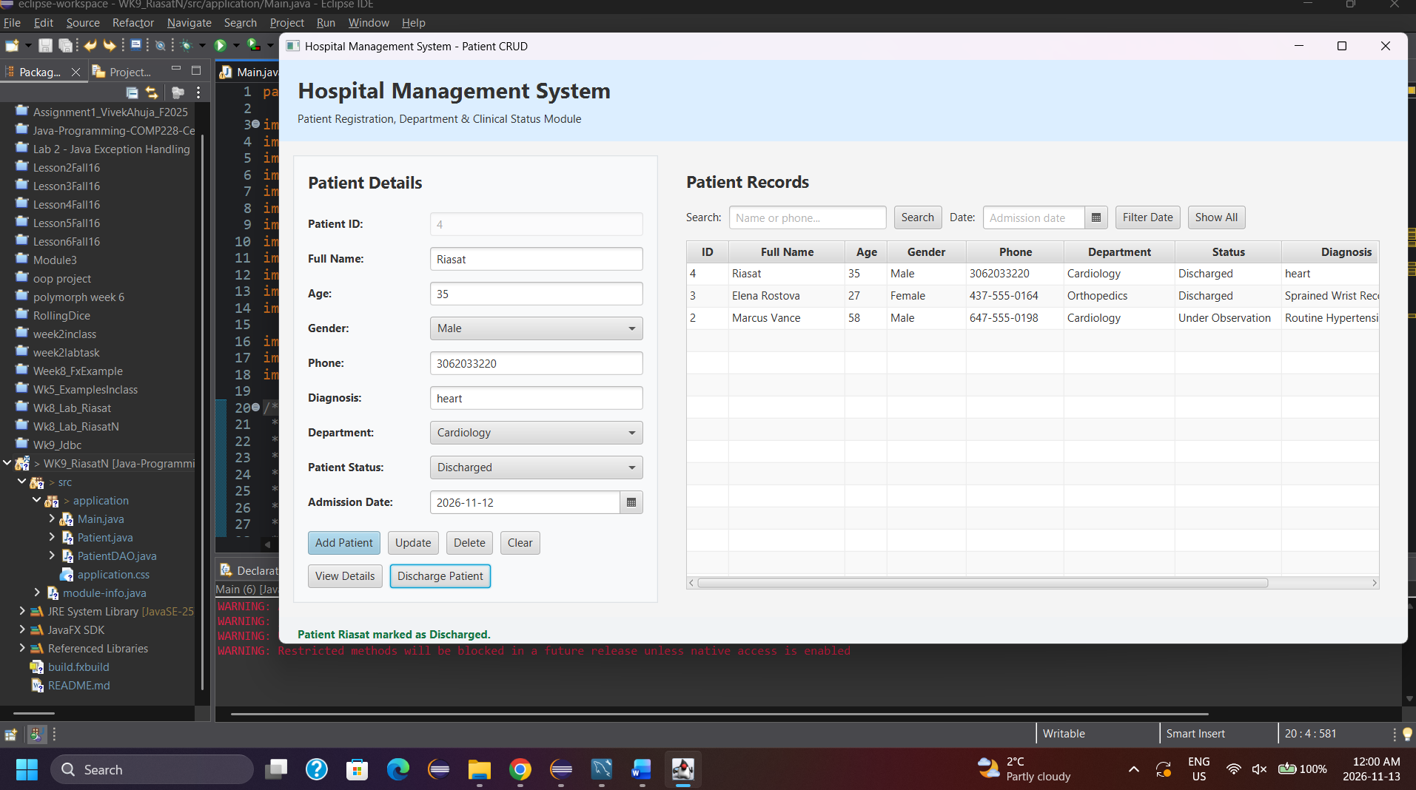
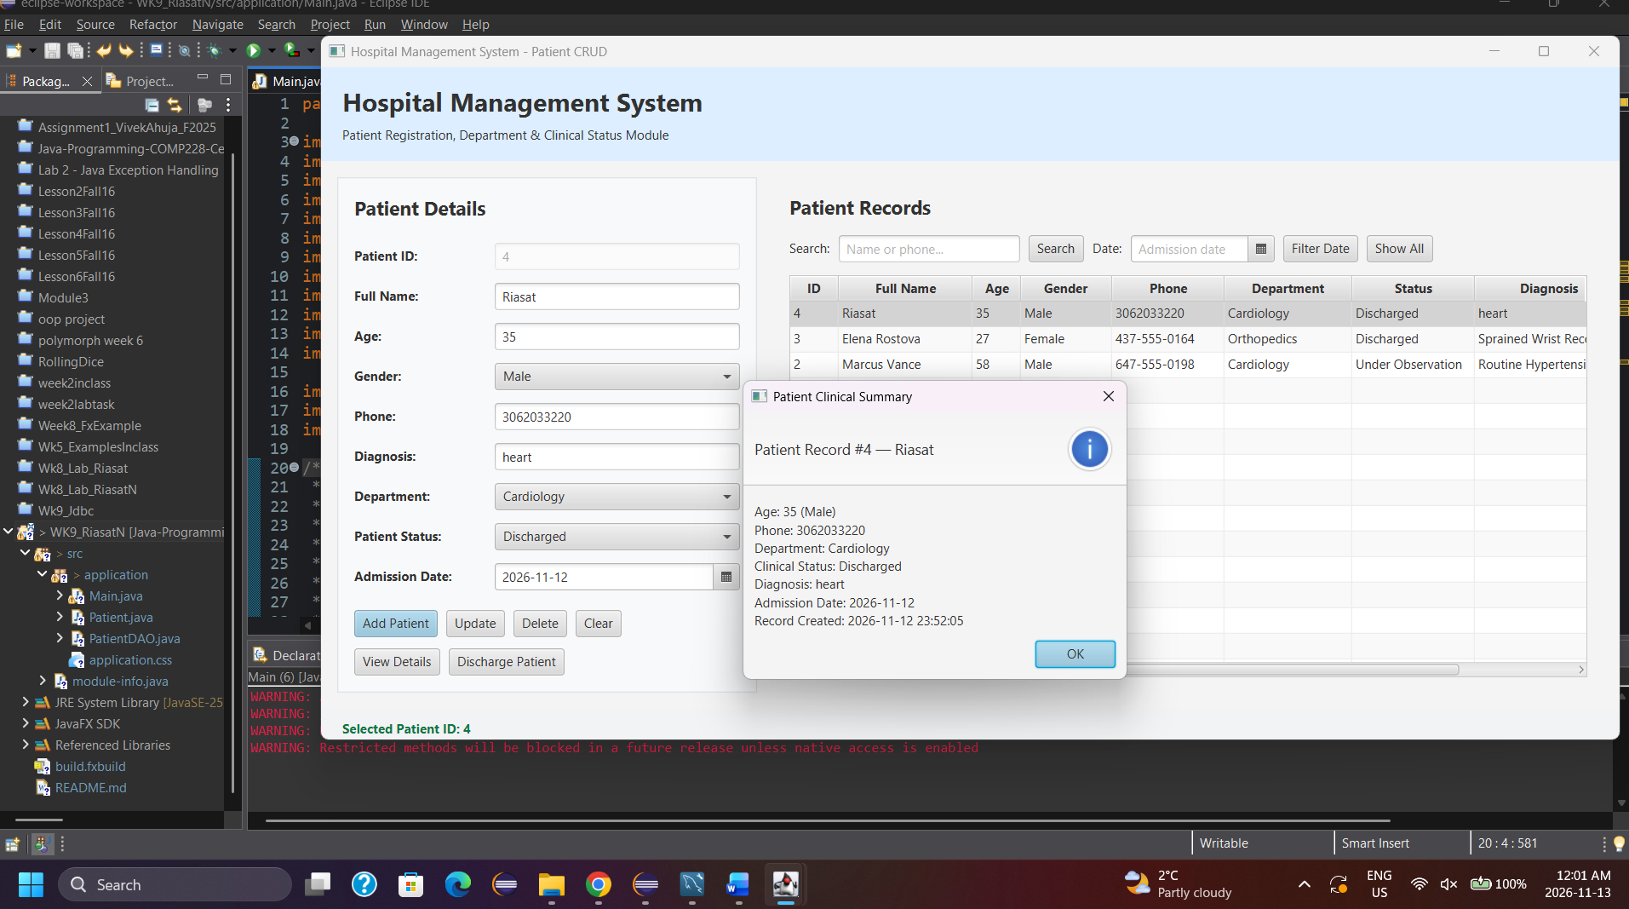
Discharge Patient updates the selected patient's status directly to 'Discharged' in MySQL, while View Details opens an informational modal summarizing the complete clinical record.

